# Generator in Python:

Python generators are a simple way of creating iterators. In general, a generator is a function that returns an object (iterator) which we can iterate over (one value at a time).

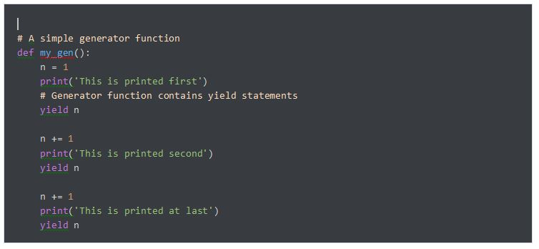

# Decorators in Python:

A decorator is a design pattern in Python that allows a user to add new functionality to an existing object without modifying its structure. Decorators are usually called you want to decorate.

